SIGAP: Design and Development of a Web and Mobile-Based Public Infrastructure Damage Reporting System with a Client-Server Architecture
Course: Mobile Programming — Client Server | Lecturer: Vitradisa Pratama, S.ST., M.T.
Muhammad Narendra Gema Akbar Raihan (230102091)  Dept. of Informatics Engineering  Universitas Muhammadiyah Bandung  Bandung, Indonesia | Zakqi Ramadhan (230102129)  Dept. of Informatics Engineering  Universitas Muhammadiyah Bandung  Bandung, Indonesia
M. Sakti Gabisa (230102131)  Dept. of Informatics Engineering  Universitas Muhammadiyah Bandung  Bandung, Indonesia | Andreansyah Rahmattullah (240102015)  Dept. of Informatics Engineering  Universitas Muhammadiyah Bandung  Bandung, Indonesia

Abstract— Damage to public infrastructure such as potholes, broken streetlights, and clogged drainage is common in Indonesian cities and campuses, yet the reporting process available to citizens is still largely manual and difficult for responsible agencies to track [1]–[4]. This project develops SIGAP (Sistem Informasi Pengaduan dan Pelaporan Infrastruktur), a client-server based infrastructure damage reporting system consisting of a web admin dashboard built with the Laravel framework and a mobile application built with Flutter, connected through a REST API secured with Laravel Sanctum authentication. The system provides features for managing reports, report categories, announcements, and user accounts with role-based access control, allowing citizens to submit and track reports while administrators monitor and follow up on them. With a three-layer architecture (presentation, application, and data layer) following the MVC pattern, this system is expected to make infrastructure damage reporting faster, more transparent, and easier to monitor compared with informal, manual reporting channels, while allowing both citizens and administrators to access consistent report data across web and mobile platforms.
Keywords— Infrastructure Reporting, Public Complaint System, Laravel, Flutter, REST API, Client-Server, System Architecture, MVC
I. INTRODUCTION
A. Background of the Problem
Public infrastructure such as roads, streetlights, and drainage systems is a shared resource whose condition directly affects the safety, mobility, and comfort of citizens. Damage to this infrastructure — potholes, broken streetlights, or clogged drainage — can hinder daily activity and, if left unattended, create additional public safety risks and economic costs.
In many regions and institutions in Indonesia, this kind of damage is still reported informally, for example through verbal complaints, social media posts, or personal messaging applications directed at local officials. This approach is prone to incomplete information, unverified reports, delayed follow-up, and difficulty tracking the status of a complaint in real time [1]–[3].
Several previous studies have developed web- and mobile-based infrastructure damage reporting systems using frameworks such as Laravel and modeling approaches such as Object Oriented Analysis and Design (OOAD), and have shown that these systems can make the reporting process faster, more transparent, and easier for responsible agencies to prioritize [1], [2]. Geographic and web-based reporting platforms integrating GIS concepts have likewise been shown to help agencies such as public works offices (Dinas PU/PUPR) and transportation offices manage and prioritize road and facility repairs more effectively [2], [3], [4]. These findings indicate that a well-designed digital reporting platform not only speeds up administrative follow-up but also improves transparency and public trust in the handling process.
Based on this background, a reporting system is needed that can be accessed not only through a web dashboard by administrators, but also through a mobile application by citizens, so that the submission, verification, and follow-up of infrastructure damage reports can be carried out more efficiently and transparently. This need becomes the foundation for the development of SIGAP, which is designed with a client-server architecture that keeps the web and mobile clients synchronized against a single, consistent data source.
B. Problem Statement
- How to design an infrastructure damage reporting system that can be accessed through both a web dashboard and a mobile application in an integrated manner?
- How to design a client-server system architecture that connects the Flutter mobile application and the Laravel backend securely through a REST API?
- How to provide role-permission access management and a report-handling workflow within the reporting system so that reports remain traceable from submission to resolution?
C. Objectives
- To build a web-based (Laravel) and mobile-based (Flutter) infrastructure damage reporting system that is integrated through a REST API.
- To implement a client-server architecture with the MVC pattern on the backend side to manage report, category, announcement, and user data.
- To provide authentication, role-permission management, and a soft-delete workflow to support the integrity and traceability of report data.
- To evaluate whether the resulting system shortens the distance between a citizen noticing a problem and an administrator being able to follow up on it, compared with informal manual reporting.
D. Scope of the System
The scope of this project covers the design and implementation of the SIGAP application, consisting of a Laravel-based web administration dashboard and a Flutter-based mobile client for citizens. Both clients communicate exclusively through a REST API protected by Laravel Sanctum. The scope includes report management with a soft-delete workflow, full CRUD management of report categories, announcements, and user accounts, dashboard statistics summarizing reports by status and category, and citizen-facing features for submitting and tracking reports. Aspects outside this scope, such as automatic routing of reports to specific field technicians or integration with external GIS/mapping services, are left as directions for future development.
II. PROPOSED SOLUTION
To address the problems described in Section I, SIGAP was developed as a client-server based infrastructure damage reporting application consisting of two main parts: a web-based admin dashboard and a mobile application for citizens. Both parts are connected through a REST API so that report data submitted through the mobile app is immediately visible to administrators on the dashboard, and status updates made by administrators are immediately reflected back to the reporting citizen.
A. Web Admin Dashboard (Laravel)
- User authentication and role-permission management (admin and citizen/user), so that each user only has access to the features relevant to their role.
- A dashboard with statistics and reports summarized by status and category, alongside a feed of the most recent reports.
- A Reports page with read and soft-delete operations, so that report history is preserved even when a report is removed from the active list.
- Full CRUD (Create, Read, Update, Delete) management for report categories, announcements, and user accounts.
- A REST API secured with Laravel Sanctum, exposed for consumption by the mobile application.
B. Mobile Application (Flutter)
- Login and registration screens, allowing citizens to create an account and authenticate securely.
- A dashboard screen summarizing the citizen's reports and relevant announcements.
- Report list, detail, creation, and editing screens, allowing citizens to submit new reports and track the status of existing ones.
- A profile screen for managing the citizen's account information.
C. Data Consistency Strategy
Because both the web dashboard and the mobile application read from and write to the same backend, all business logic and validation rules — such as report status transitions and category assignment — are centralized on the Laravel server rather than duplicated on each client. This design choice reduces the likelihood of inconsistent validation between platforms and simplifies future maintenance, since any change to reporting rules only needs to be implemented once, on the server side, to be immediately reflected on both clients.
III. SYSTEM ARCHITECTURE
The architecture of the SIGAP system is designed using a three-layer client-server pattern, namely the presentation layer, application layer, and data layer, as illustrated in Fig. 1.

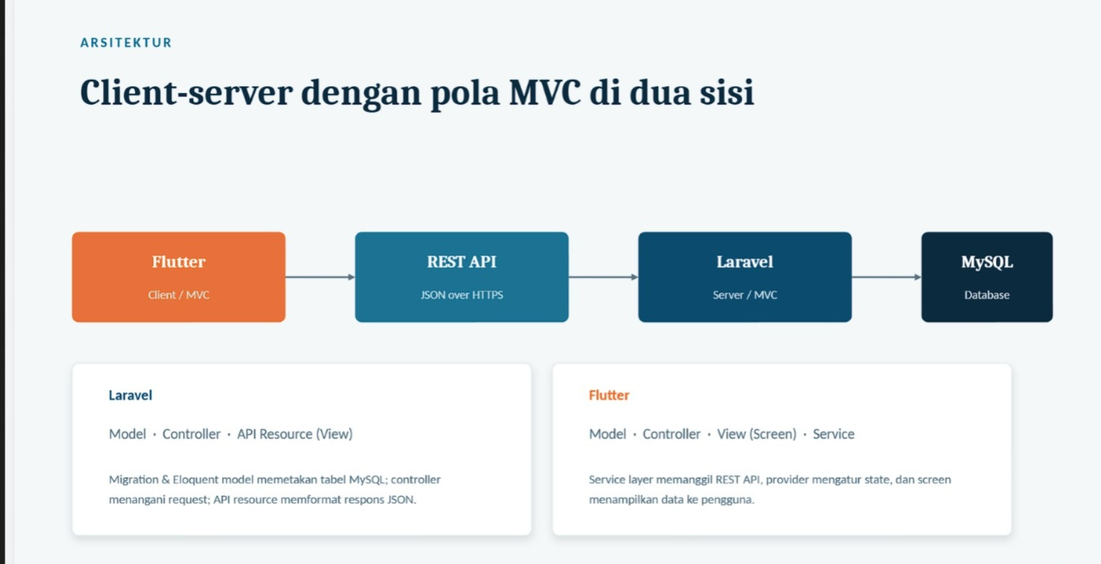
Fig. 1. SIGAP System Architecture (Client–Server, MVC).
Broadly speaking, the intended architecture flow works as follows. The user accesses the system through two types of clients: the Flutter mobile application (with Login, Dashboard, Report, and Profile modules) used by citizens, and the Laravel web application (with Dashboard, Report, Category, Announcement, and Manage User modules) used by administrators. Both clients communicate with the Application Layer (Laravel Backend) through the REST API and its associated API routes.
At the application layer, the Model-View-Controller (MVC) pattern is applied, where every incoming request is routed to the appropriate controller — namely the Auth, Report, Category, Announcement, and User controllers. Each controller interacts with the corresponding models to process business logic, which is then stored in and retrieved from the MySQL database at the data layer.
This layered separation offers several benefits. First, it makes the codebase more structured and easier to maintain, since presentation logic, business logic, and data access are clearly separated. Second, it allows the mobile and web applications to share the same single source of data consistently, so that a report submitted through the mobile app is immediately visible on the web dashboard. Third, it improves testability, because each controller and model can be validated independently before being integrated with the user interface.
From a security standpoint, every request that reaches the application layer must first pass through Laravel Sanctum's token-based authentication middleware, ensuring that only verified and authorized users — whether accessing the system from the web dashboard or the mobile application — are able to read or modify report data.
IV. RESEARCH METHODOLOGY
A. Development Approach
SIGAP was developed following an iterative, module-by-module development approach across two integrated platforms. Each module (Report, Category, Announcement, User) was designed, implemented on the Laravel backend, exposed through a REST API endpoint, and subsequently consumed by the corresponding screen on the Flutter mobile client, so that backend and mobile development could proceed in parallel once the API contract for a module was defined.
B. Tools and Technology Stack
- Backend / Web Dashboard: Laravel 13, PHP 8.4, MySQL 8, and Tailwind CSS.
- Mobile Application: Flutter (project SIGAP), organized using a controller–service–model–view structure for communication with the REST API.
- Authentication: Laravel Sanctum, providing token-based authentication shared between the web dashboard and the mobile application.
C. Data Consistency and Validation Strategy
As outlined in Section II.C, all business logic and validation rules are centralized on the Laravel server rather than duplicated on each client, so that both the web dashboard and the mobile application always operate against the same validated data source.
D. Testing Method
Functional testing was carried out on both platforms to confirm that CRUD operations, authentication, and role-based access behave as expected. On the backend, endpoint responses were verified against the intended HTTP status codes and payload structures for both successful and invalid requests. On the mobile client, manual testing was performed across the login flow, report submission, and API connectivity to ensure that a report entered on the mobile app is correctly reflected when viewed from the web dashboard, confirming the intended single-source-of-truth behavior of the client-server design.
V. FEATURE IMPLEMENTATION
The system was implemented on two integrated platforms. On the backend side, every API endpoint is secured using Laravel Sanctum so that only authenticated users can access the data. On the mobile side, the Flutter application uses the api_service, auth_controller, and report_controller modules to communicate with the backend.
A. Web Backend (Laravel 13, PHP 8.4, MySQL 8, Tailwind CSS)
- Authentication and role-permission management, allowing administrators to control which features each role is allowed to access.
- A dashboard with statistics and reports summarized by status and category, along with a feed of the most recent reports.
- A Reports page with read and soft-delete operations to preserve report history.
- Full CRUD management for report categories, announcements, and user accounts, each equipped with input validation to maintain data quality.
- A REST API based on Laravel Sanctum, structured by resource, for consumption by the mobile application.
B. Mobile Application (Flutter — SIGAP)
- Login and registration screens, including session handling so that authenticated citizens remain logged in between sessions.
- A dashboard screen, along with report list, detail, creation, and editing screens connected to the backend through the REST API.
- A profile screen for managing citizen account information.
- Connectivity to the Laravel backend through dedicated api_service, auth_controller, and report_controller modules, which keep networking logic separated from the user-interface code.
C. Security Implementation
Security is addressed at multiple levels. At the authentication level, Laravel Sanctum issues per-user API tokens so that every request from the mobile client can be verified without exposing session cookies across platforms. At the authorization level, role-permission checks are enforced on the backend before any CRUD operation is executed, so that a citizen user attempting to access an administrator-only feature is rejected regardless of what the client interface displays. At the data level, the soft-delete mechanism on the Reports page acts as a safeguard against accidental permanent deletion.
D. Testing and Evaluation
Functional testing was carried out on both platforms to confirm that CRUD operations, authentication, and role-based access behave as expected. On the backend, endpoint responses were verified against the intended HTTP status codes and payload structures for both successful and invalid requests. On the mobile client, manual testing was performed across the login flow, report submission, and API connectivity to ensure that data entered on one platform is correctly reflected when viewed from the other.
VI. RESULTS AND DISCUSSION
The implementation results show that SIGAP successfully connects a Laravel-based web dashboard and a Flutter-based mobile application through a single REST API, so that report data submitted from the mobile app is immediately consistent on the web dashboard. This addresses the first problem stated in Section I.B, namely the need for an integrated access channel for infrastructure damage reporting.
The three-layer, MVC-based architecture described in Section III proved effective in separating concerns between presentation, business logic, and data storage. This separation simplified the implementation of new features during development, since changes to a controller's business logic did not require modifications to the corresponding views on either the web or mobile side, as long as the API contract remained unchanged.
The role-permission mechanism and the soft-delete workflow for reports also address the second and third problem statements. By centralizing authorization checks on the backend and preserving report history rather than deleting it outright, the system reduces the risk of unauthorized access and keeps every report traceable from submission to resolution — an issue that is difficult to control in a purely informal, message-based reporting process.
Compared with the informal reporting channels described in the background section, SIGAP offers faster and more structured access to report information, consistent data across access channels, and a clearer status trail for both citizens and administrators. Nevertheless, the current implementation is limited to the modules described in Section V; features such as automatic geolocation tagging, push notifications, and integration with external GIS mapping services remain open areas for further development.
VII. CONCLUSION AND SUGGESTIONS
A. Conclusion
SIGAP is a client-server based infrastructure damage reporting system consisting of a web admin dashboard (Laravel) for managing reports, report categories, announcements, and user accounts supported by a role-permission system, as well as a mobile application (Flutter) that consumes the backend's REST API to make infrastructure damage reporting easier for citizens on mobile devices.
With a three-layer architecture following the MVC pattern, this system is expected to address the problems of informal infrastructure damage reporting, such as incomplete information, delayed follow-up, and lack of transparency, while providing flexible and consistent data access across two different platforms.
B. Suggestions
Future development may extend the system with automatic geolocation tagging for reports, push notifications for status updates, and integration with GIS-based mapping services to visualize report locations for responsible agencies. In addition, an automated testing pipeline is recommended to further improve the reliability of the system before it is deployed at a larger production scale.
REFERENCES
[1] V. R. Yuniar, R. I. Qonata, H. A. Rizmadita, and A. S. Fitri, "Perancangan sistem pelaporan kerusakan jalan dengan metode Object Oriented Analysis Design (OOAD) berbasis web," JATI (Jurnal Mahasiswa Teknik Informatika), vol. 8, no. 1, pp. 975–981, 2024.
[2] I. L. Kharisma, A. K. Arrahman, Hermanto, and Kamdan, "Sistem informasi geografis pemetaan dan pelaporan kerusakan jalan di wilayah Kecamatan Bayongbong berbasis web," J. Restikom: Riset Teknik Informatika dan Komputer, vol. 3, no. 3, pp. 150–159, Dec. 2021.
[3] D. F. R. A. Harahap, Mhd. F. Ridho, S. Alfarezy, and I. A. Sinaga, "Rancang bangun aplikasi berbasis web pelaporan kerusakan berkonsep GIS pada Dinas PUPR Sumut," JUTECH: Journal Education and Technology, vol. 5, no. 1, pp. 169–182, 2024.
[4] M. Ikhsan, "Aplikasi pengaduan jalan rusak berbasis GIS (Geographic Information System) (studi kasus: Dinas Bina Marga Provinsi Lampung)," Jurnal Teknologi Pintar, vol. 1, no. 1, Jun. 2022.

